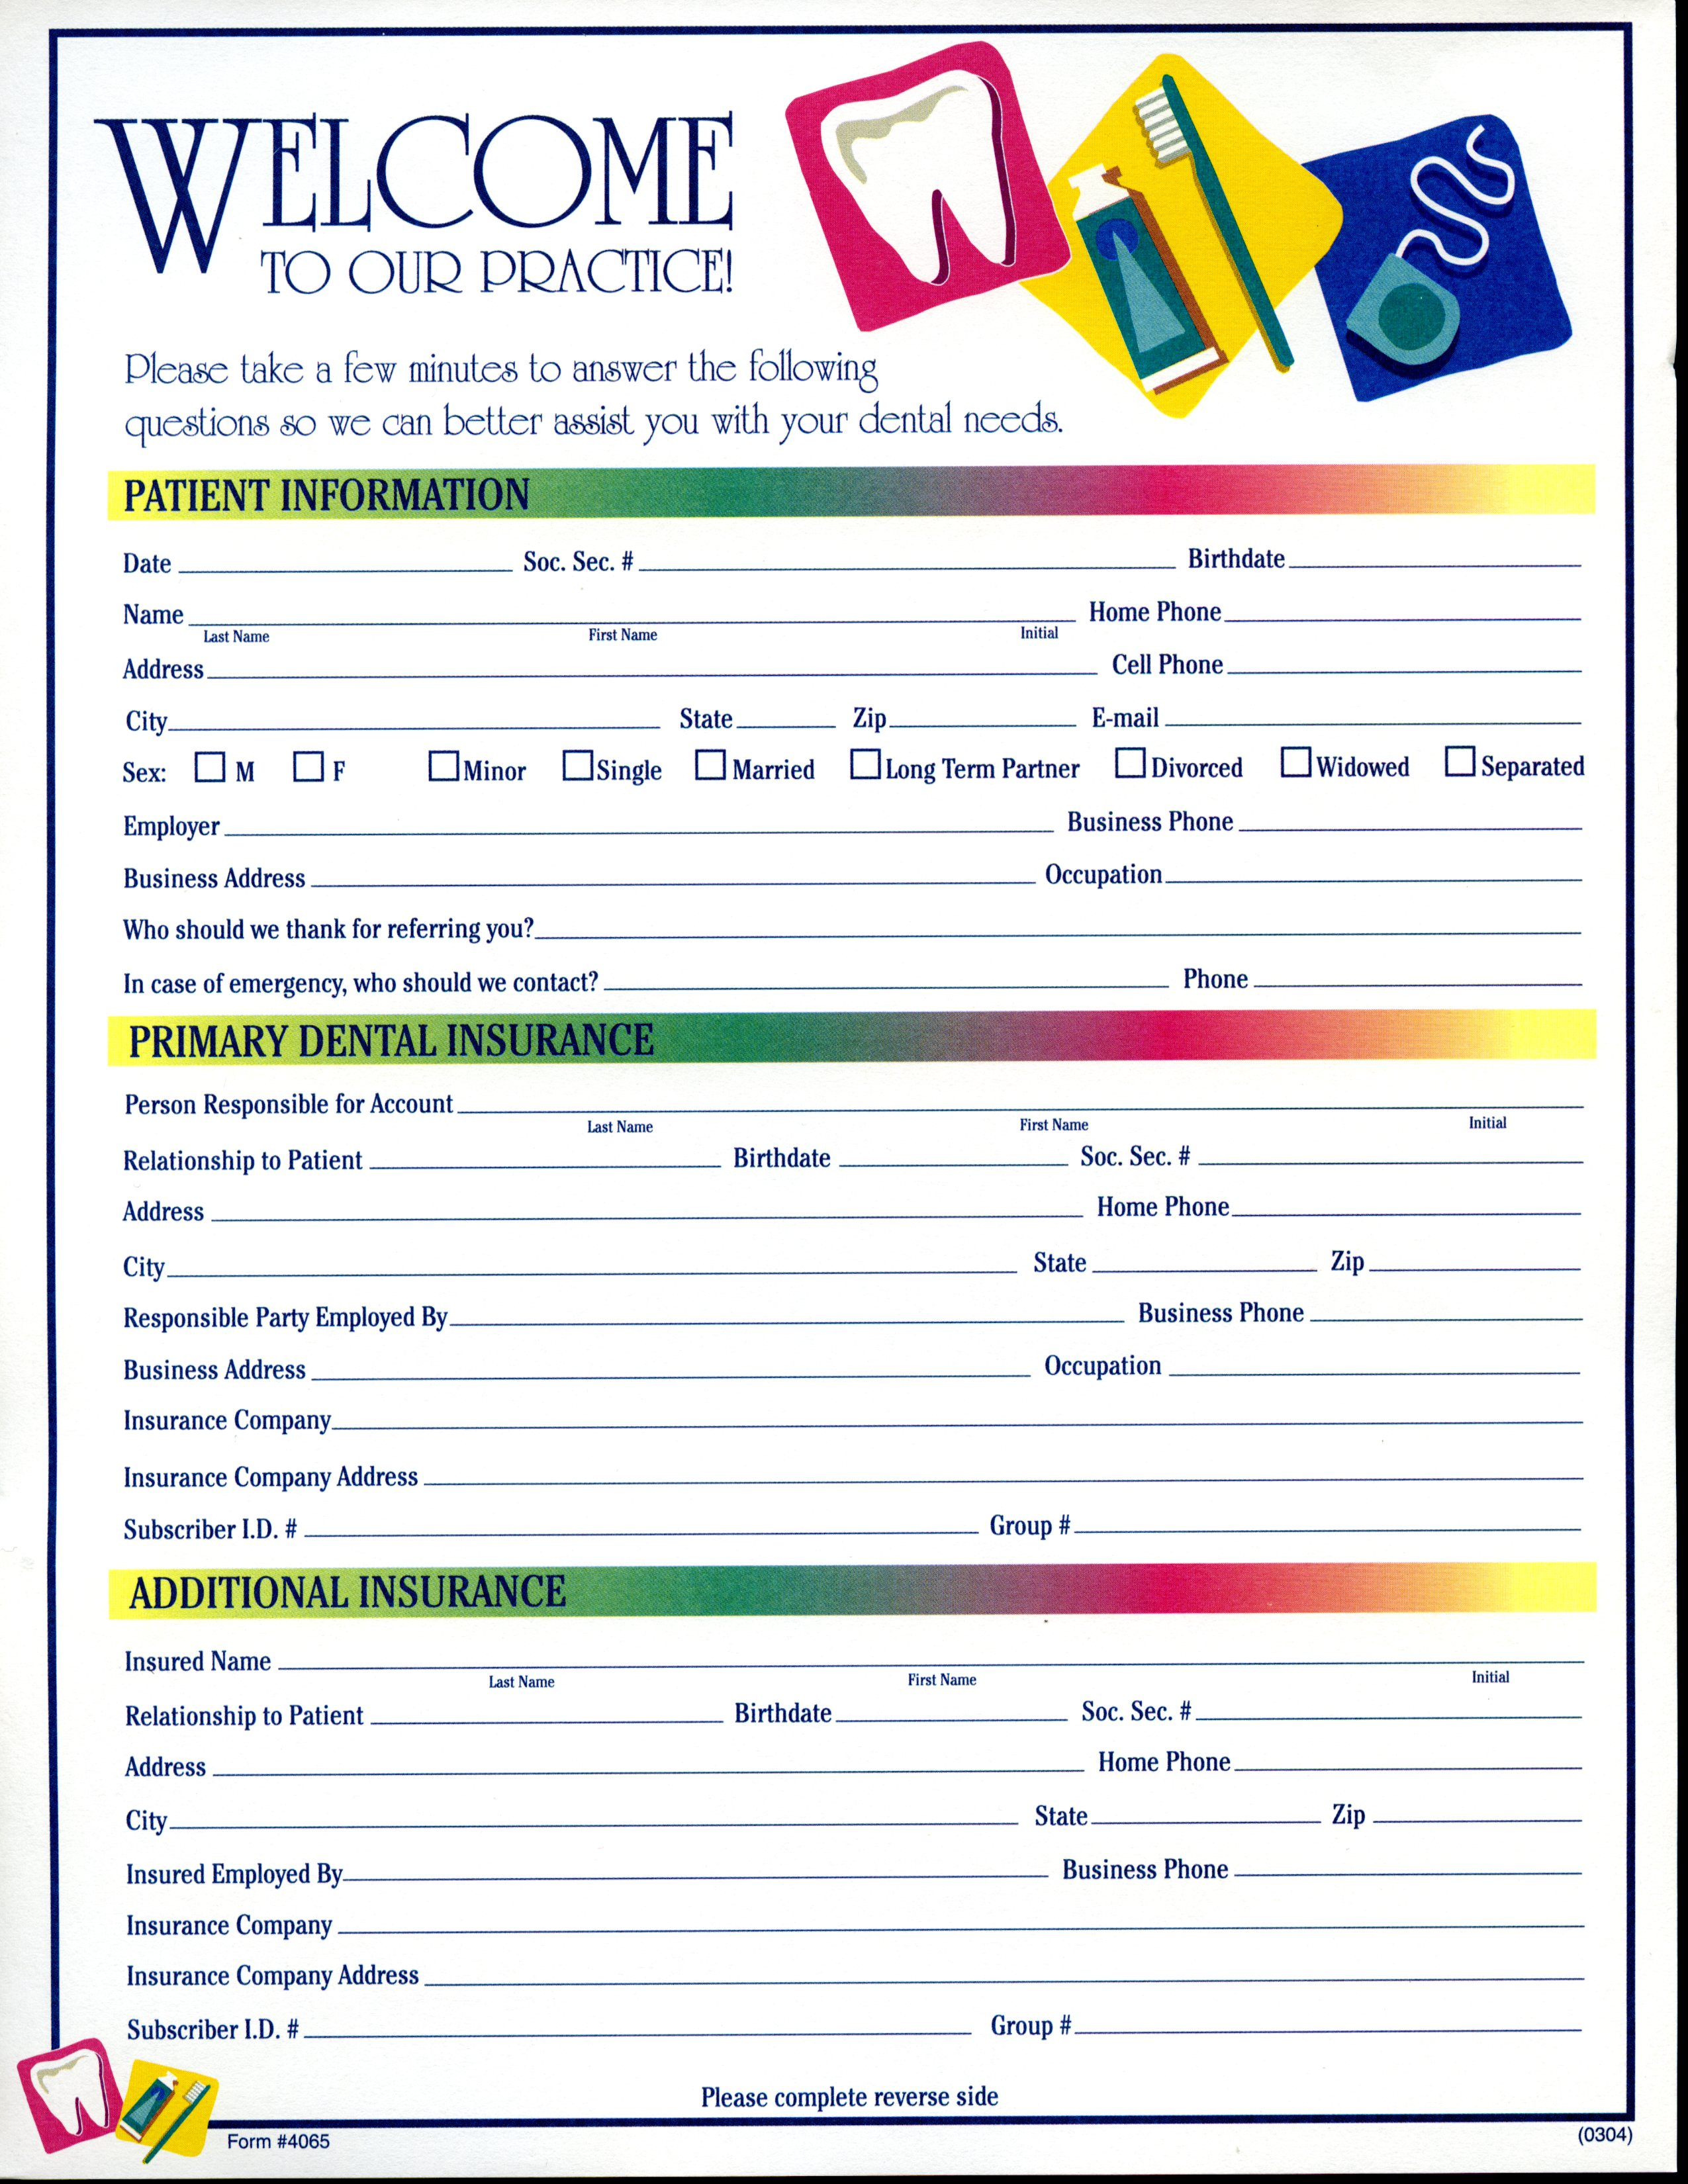
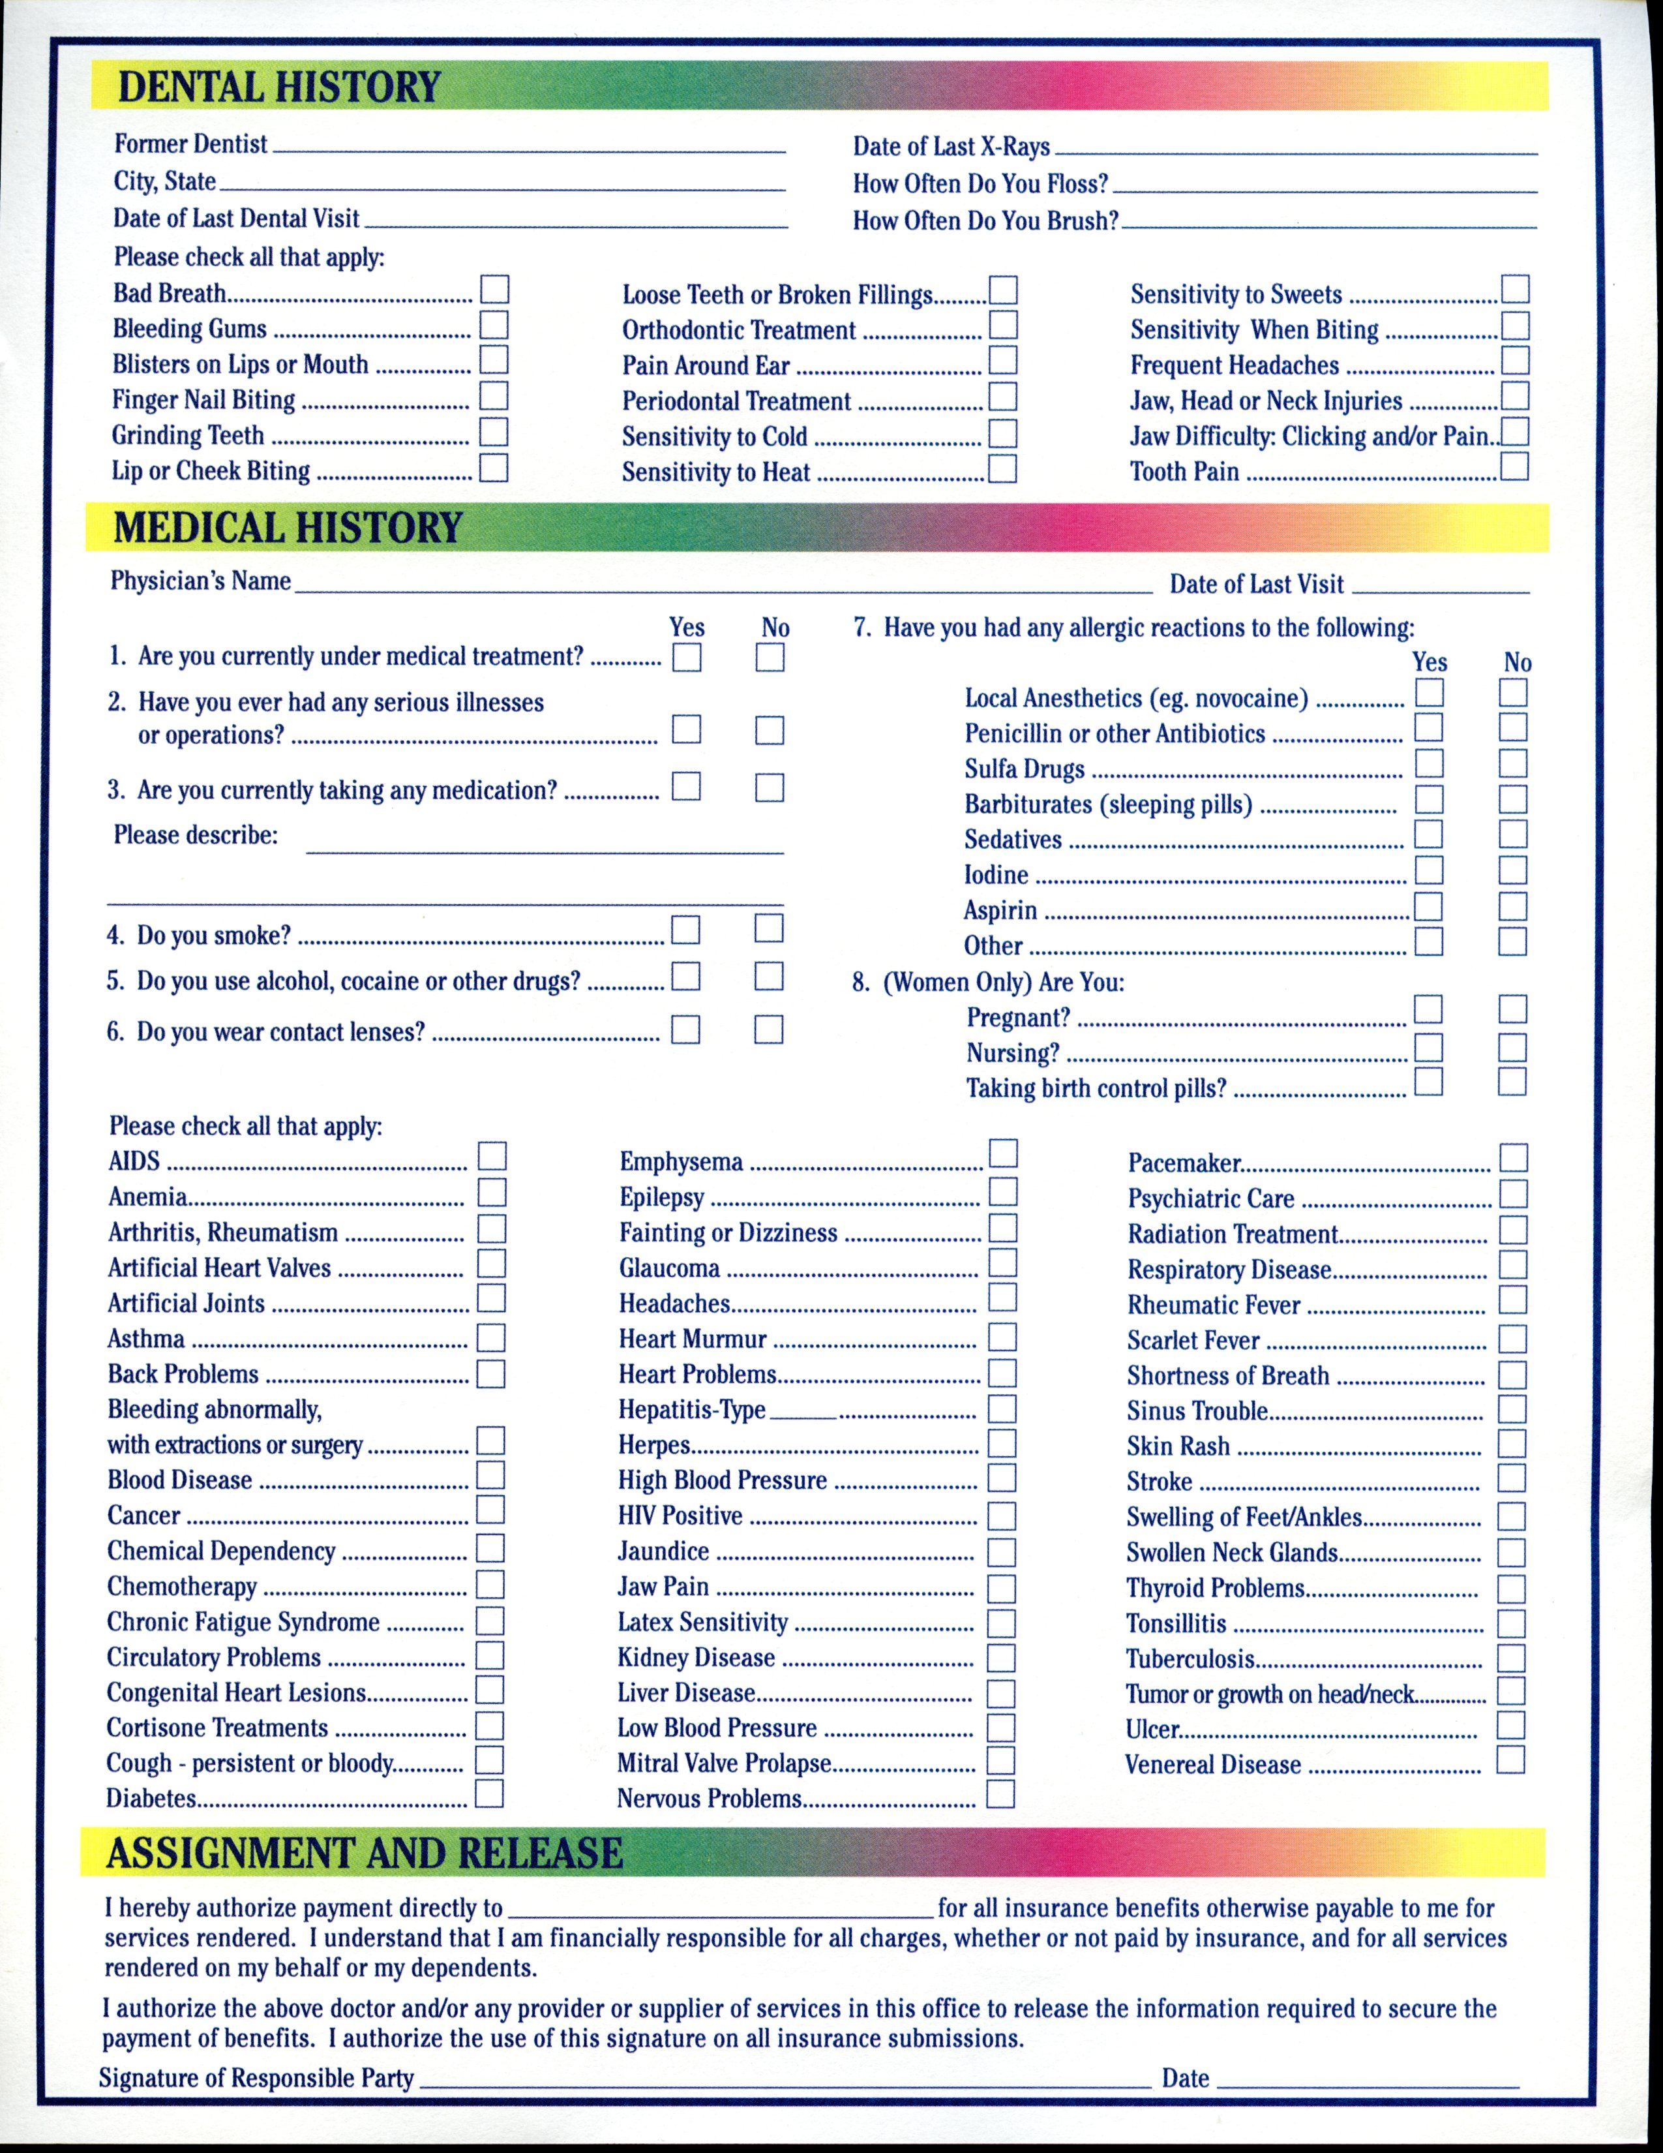

C. Heather Colson, DMD, PC
ACKNOWLEDGEMENT OF RECEIPT OF NOTICE OF PRIVACY PRACTICES

** You May Refuse to Sign This Acknowledgement**

I, ________________________________, have received a copy of this office’s Notice of Privacy Practices.

____________________________ I give permission for Dr. Colson and staff to
{Please Print Name} speak with the following persons regarding
my dental care:
_____________________________ _____________________________
{Signature} _____________________________
_____________________________
_____________________________
{Date}

For Office Use Only

We attempted to obtain written acknowledgement of receipt of our Notice of Privacy Practices, but acknowledgement could not be obtained because:

- Individual refused to sign
- Communications barriers prohibited obtaining the acknowledgement
- An emergency situation prevented us from obtaining acknowledgement
- Other (Please Specify)

©2002 American Dental Association
All Rights Reserved

Reproduction and use of this form by dentists and their staff is permitted. Any other use, duplication of this form by any other party requires the prior written approval of the American Dental Association.

This for is educational only, does not contain legal advice, and covers only federal, not state law (August 14,2002)
C. Heather Colson DMD, PC

CONSENT FOR USE AND DISCLOSURE OF HEALTH INFORMATION

SECTION A: PATIENT GIVING CONSENT

NAME: ____________________________________________________________________________________________________

ADDRESS: _________________________________________________________________________________________________

TELEPHONE: ______________________________________________________________________________________________

PATIENT #: ________________________________________________ SOCIAL SECURITY#: ___________________________

SECTION B: TO THE PATIENT- PLEASE READ THE FOLLOWING STATEMENTS CAREFULLY

Purpose of Consent: By signing this form, you will consent to our use and disclosure of your protected health information to carry out treatment, payment activities, and healthcare operations.

Notice of Privacy Practices: You have the right to read our Notice of Privacy Practices before you decide whether to sign this Consent. Our Notice provides a description of our treatment, payment activities, and healthcare operations, of the uses and disclosures we may make of your protected health information, and of other important matters about your protected health information. A copy of our Notice accompanies this Consent. We encourage you to read it carefully and completely before singing this Consent.

We reserve the right to change our privacy practices as described in our Notice of Privacy Practices. If we change our privacy practices, we will issue a revised Notice of Privacy Practices, which will contain the changes. Those changes may apply to any of your protected health information that we maintain.

You may obtain a copy of out Notice of Privacy Practices, including any revisions of our Notice, at any time by contacting:

Contact Person: MaryAnn George

Address: 3000 North Patterson Street Valdosta, Georgia 31602

Telephone: 229-242-2449 Fax: 229-242-2699

Email: drcolson@bellsouth.net

Right to Revoke: You will have the right to revoke this Consent at any time by giving us written notice of your revocation submitted to the Contact Person listed above. Please understand that revocation of the Consent will not affect any action we took in reliance on this Consent before we received your revocation, and that we may decline to treat you or to continue treating you if you revoke this Consent.

SIGNATURE

I, _________________________________________, have had full opportunity to read and consider the contents of this Consent form and your Notice of Privacy Practices, I understand that, by signing this Consent form, I am giving my consent to your use and disclosure of my protected health information to carry out treatment, payment activities, and health care operations.

Signature: __________________________________________ ______________Date: ____________________________________

If personal representative on behalf of the patient signs this Consent, complete the following:

Personal Representative’s Name: _______________________________________________________________________________

Relationship to Patient: _______________________________________________________________________________________

OFFICE FINANCIAL POLICY

- Payment is expected in full by cash or credit/debit card at each appointment as service is rendered. For your convenience, Visa, Discover, MasterCard are accepted. WE DO NOT ACCEPT CHECKS.

- We will be happy to file your insurance claim on the first visit if we have received all or cancel insurance information. You will need to be prepared to pay any amount that is determined not payable by your insurance plan, such as deductible and co-pay percentages.
- To ensure prompt and efficient patient care, we require 24 hour notice to reschedule or cancel appointments. A $50.00 reactivation fee may be assessed in order to reschedule if 24 hour notice is not given. Failure to give 24 hour notice or being a “no show” for two appointments will result in dismissal from our practice.

- We must emphasize that as health care providers, our relationship is with you, not your insurance company. Your insurance is a contract between you, your employer, and the insurance company. We are not a party to that contract. You are ultimately responsible for checking with your insurance company regarding coverage. Pre- treatment estimates through your insurance company are encouraged as we can only give you an estimate of what your insurance will pay on procedures, based on information that you provide.
- The amount not covered by your insurance is payable at the time of services, such as deductible and co-payments. However, if we do not receive payment from the company within 40 days after the submission of a claim, you will be expected to pay for all dental services in full within 10 days of notification. In the event of duplicate payment, you will be reimbursed.
- You are responsible for payment regardless of any insurance company’s arbitrary determination of fees. Please be aware that some services provided may be non-covered service by your dental insurance carrier. It is you responsibility to know your plan.
- Accounts over 90 days are referred to an outside collection agency for collections. Patient/ Parent responsible for all collection fees, agency fees and attorney court costs involved in collection.

I have read and understand the Office Financial Policy and agree to abide by its contents.

AUTHORIZATION FOR TREATMENT
I hereby authorize Dr Heather Colson to administer such medication and perform such diagnostic, photographic, and therapeutic procedures as may be necessary for proper dental care. The information provided in the patient registration for and the dental/medical histories are correct and to the best of my knowledge. I grant the right to the dentist to release my dental/ medical histories and other information about my dental treatment to third party payors and/or other health professionals.

Patient/ Parent or Guardian Signature _____________________________________________ Date_________

Patient Consent For Electronic Communication

You have requested that our practice communicate with you electronically. By utilizing our practice’s electronic services, you agree that Dr. C. Heather Colson, DMD, PC, may send you any of the following that you identify as communication that can be sent through the Internet to an email address you designate.

Consent and Acknowledgement

I, ______________________________, in the presence of my dentist or the dental practice’s privacy official, agree that the practice may electronically communicate with me at the following email address.

Email Address: _________________________________________________________________

Patient Date of Birth (for verification purposes): _______________________________________

I acknowledge that the practice may send the following to my email. Check each that apply, and then provide your initials at the end of each item selected.

- Information about my invoice or accounts payable. _______________(Initials)
- Information about a specific dental visit. _______________(Initials)
- Information about my dental visit. _______________(Initials) Specify: ______

Acknowledgement

You must acknowledge each of the following before we can send communications electronically.

_______ All electronic communications from our practice will be encrypted.
_______ I am responsible for providing the dental practice any updates to my email address.
_______ I am able to receive information electronically and store it securely away from any public computer.
_______ I can withdraw my consent to electronic communications by calling (229) 242-2449

Patient’s Signature: ____________________________________________Date: _____________

If you do not want Electronic Communications
Please Complete The Following:

- I do not want electronic communications:

Patient’s Signature: ____________________________________________Date: _____________

